Agroverse.com

Header:

“Discover the Richness of Our Cacao nibs Orchard

Welcome to Agroverse: Discover the Essence of Sustainable Superfoods”

Change tips: the word discover is repeated above and down the name Agroverse.

The idea is to promote the cacao and the nibs in a different section.

Example:

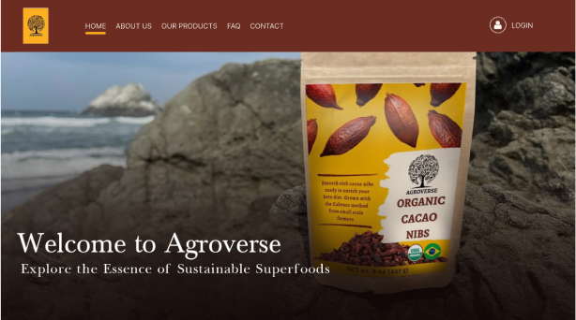

Second section

“The Heroes of Cacao Nibs”

Change tips:

Meet our Cocoa locals producers

Third section

“Support your Taste

Build a connection with your taste and its providers.

**​**Bahia Cacao, an indigenous group of cacao growers who are paving their gold into your cup, are looking for people who will champion them into the world.”

CTA button: “Start now”

Analysis:

To connect the title and the body text with the process that is presented.

*It start with 1 and goes from 3 to 5. But there are only 4 steps. Corrected already*

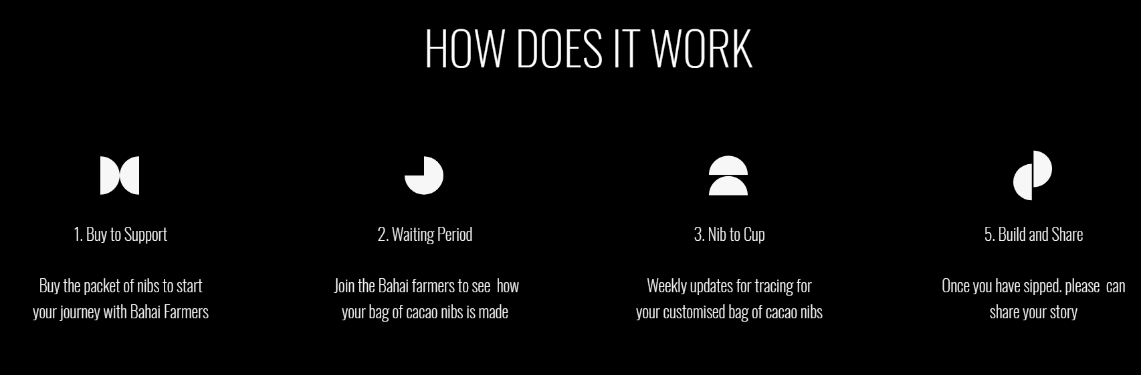

The process enables the consumer to see the whole process of what they are buying. It brings transparency to the whole process.

At the current text, the actions are not clear. First it is about supporting the producers and then, once the user press the CTA button the message is about seeing the process, being aware of it. Just at the end we can see the text “buil and share”.

So as the message is not clear we may question:

* Will the user support the farmers or will the buyer support the farmers by purchasing the products? If we follow the process and think about the support through the purchase, it makes sense to have it clear and then, show the process.
* If the 5th step “build and share” is the main point of the support, then it should be clear that sharing the stories are important as a way to help building the agroverse community.

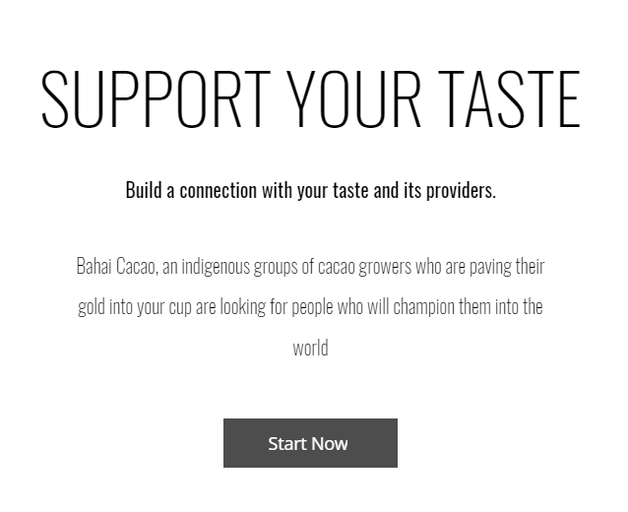

Change tips:

To connect the title and the body text with the process that is presented*.

**​** Build a connection with your taste and its providers by experiencing your product process. From farm to table, track your purchase across the farmers' hands to traveling routes. Start your sustainable journey.

OR

Build a connection with your taste and its providers by experiencing your product journey. From production to delivery, you will have the opportunity to know what goes on your table. Start right now this immersive experience.

All in the same section and leading to the shop. It is not necessary to use a CTA button when the connected text is just written down. But we can be a good use to redirect to the shop or just use no CTA button at all*

Decision taken:

The text was changed because Bahia Cacao is not a group of people. They are people from Bahia. Their products can be called Bahia Cacao, not them. They are not a indigenous group. They are locals and belong to na association. The text was rewritten in order to make it clear to the user as the marketing is already going on and it gives false information. Bahai mispelled is a religion and this is in great part the experience Agroverse differentiation of user experience.

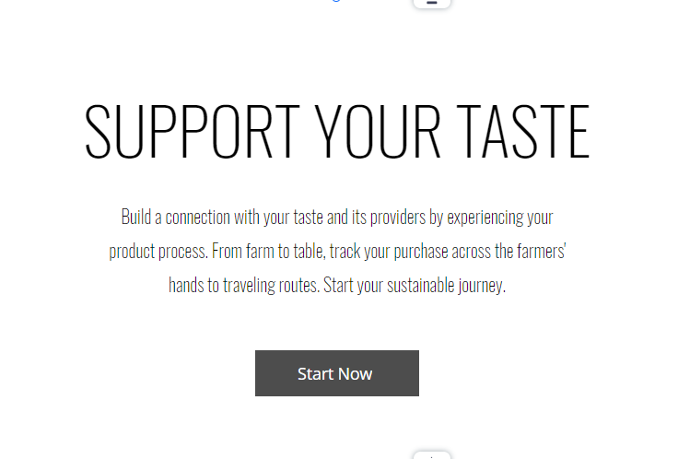

Third section corrections misspelling:

Original:

1. Buy to Support

Buy the packet of nibs to start your journey with Bahai farmers

2. Waiting Period

Join the Bahai farmers to see how your bag of cacao nibs

is made

3. Nib to Cup

Weekly updates for tracing for customised bag of cacao nibs

4. Build and Share

Once you have sipped, please can share your story

Change tips:

1. Buy to Support (misspelling correction, text remains the same)
2. Prepare together -> Time to join Bahia farmers and see how your bag of cacao nibs is made. It is important to mention how. Through the platform? Through a link*
3. Nib to Cup -> Receive weekly tracing updates on your product location (the text is not clear...only customized bags of cacao nibs can recieve the update?). The Nib to cup is still a waiting period as the packages are not into the purchaser hands. So it makes sense to change the name of the number 2 step.

4. Build and Share

Once you have shipped, share your story tagging @agroverse.shop and helps us build our community.

If you want something more consistent, you should incentivate people to share their stories through marketing campaign or if you don’t want to compromisse that much, having some of their testimonials on the site gives you credibility.

Right now, where people should know where or how to share? And build what? A fair economy in developing countries? In Brazil? If yes, I recommend using “Share and Build”,

And then explain what to build...

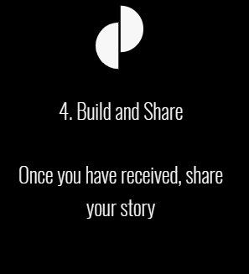

Fourth Section

About Us

I have seen the chocolate infographic it is one of the most important things because it compares the existing models with the agroverse model.

An explanation would make it easier for users to understand what the Agroverse model means. The information is simple but a little text would make it easier to understand why Agroverse is better than the existing models and better for whom. Also, it should be visible and no need to be dynamic.

About US is an important part o the site, as it explains what is agroverse compared to other models and what are the goals or the mission.

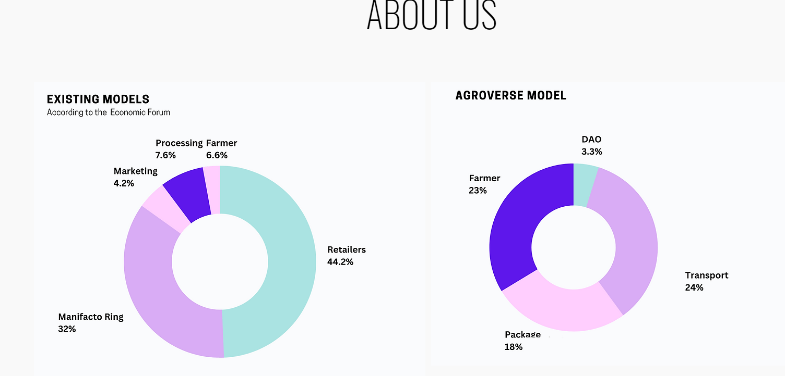

This banner is incorrect:

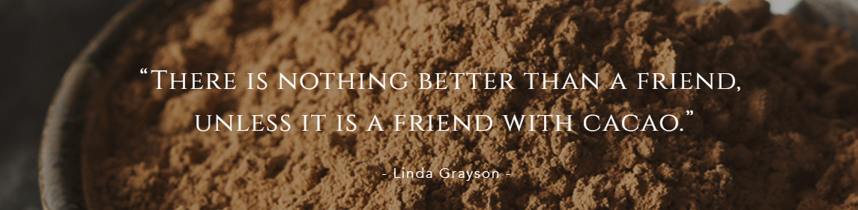

Linda Grayson said “...A friend with chocolate”. Cacao and chocolate are not the same.

Cacao powder and chocolate powder are not the same. If it’s labeled as chocolate powder, it is expected to have more ingredients than cacao. Even sugar.

The contrast is poor so it gets hard to seen. I vote for adding contrast or changing the picture/cacao for the real quote= chocolate. Or choosing a new one, as nibs are not considered chocolate and you are not selling chocolate yet.

Our Cacao Beans Section

“Share your experiences”. Here there is another invitation for sharing experiences but there is not place saying where this experiences can be shared.

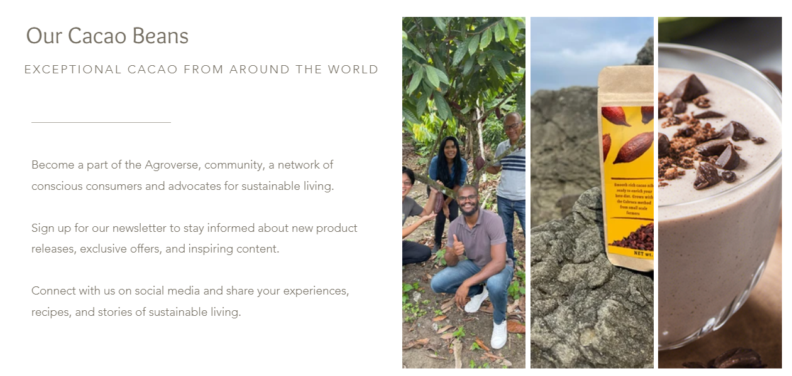

About the design:

* Applying contrast on the pictures where texts are written above
* Adding a section called: what are superfoods? What are the benefits?

If Agroverse sells superfoods, it is interesting to think about people who may not know about yet but were recommended, heard of...So they can get some info about it, as cocoa nibs are considered superfoods.

* Give more contrast to the title “ARGOVERSE CACAO ORCHARD” and feature the infographic with a simple text máx 2 lines explaning it.
* The font makes it is really hard to read sometimes and it gets worse when you have more than 4 lines in a section.
* Free Font option: Fair Display (regular)

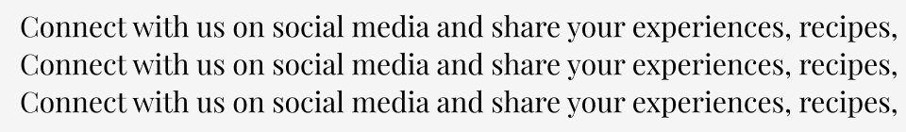

* Font option: Noto Sans

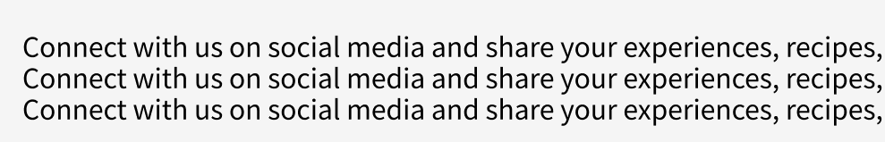

* Font option: Montserrat

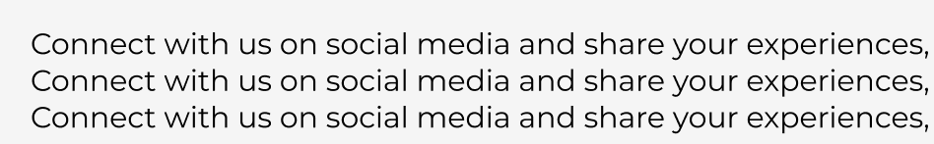

Current font is extra light*

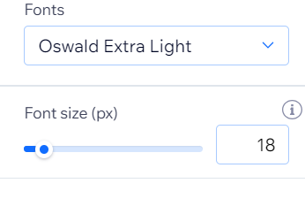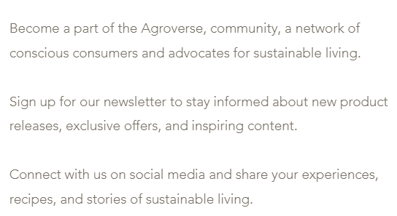

Last section (home)

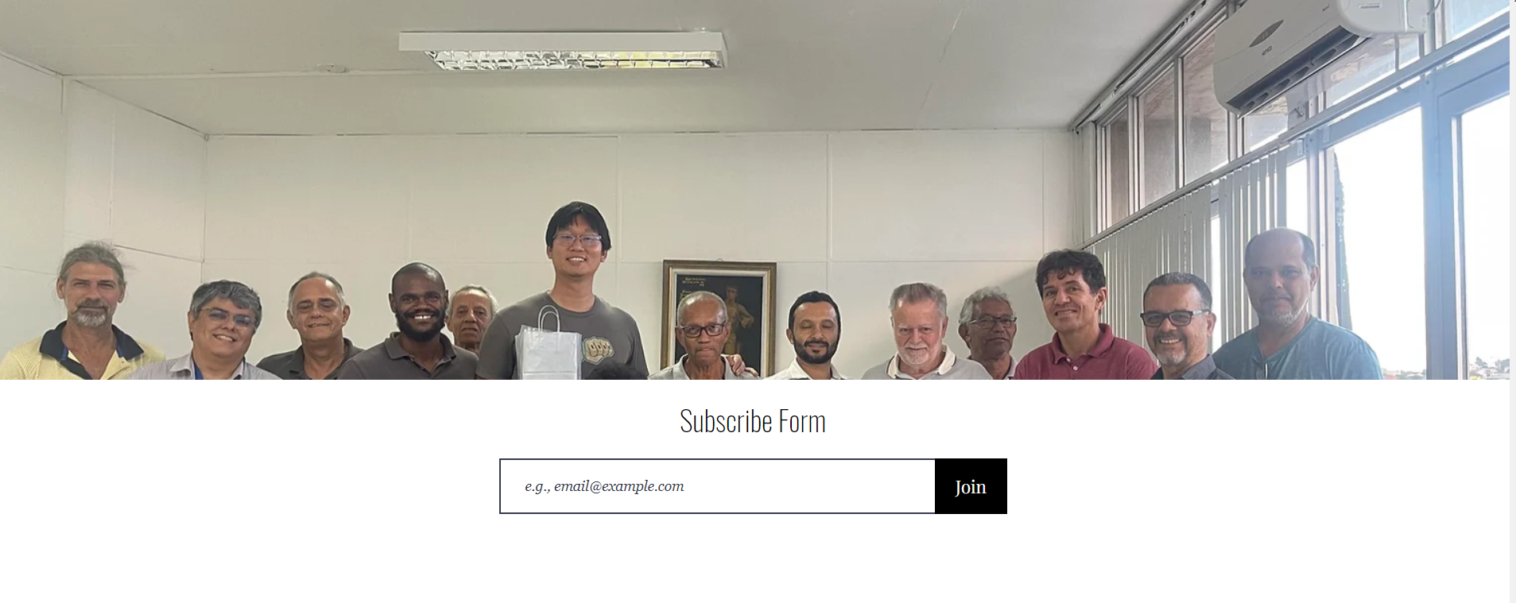

Subscribe form to what? News? So “Subscribe to our news”

Picture doesn’t say much but we know there is na asian guy in many pictures...Maybe he is the CEO? “Farmers association – name of the associaciation, Bahia, Brazil”.